# How to get a GitHub repository on to your computer

It’s called “cloning” a repository.

In your computer’s file navigator, navigate to the folder you want your repository to be in.

For this example, mine is C:\Users\worki\Documents\CIS104. Copy the location “C:\Users\worki\Documents\CIS104”.

Use command prompt to navigate to the same folder.

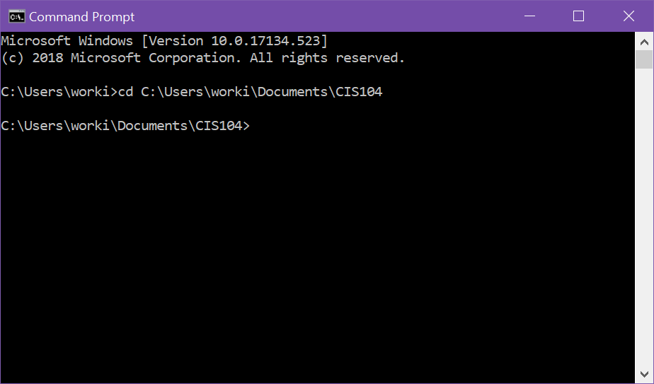

From your GitHub Repository, click on “Clone or Download”.



Click on the Copy URL button.

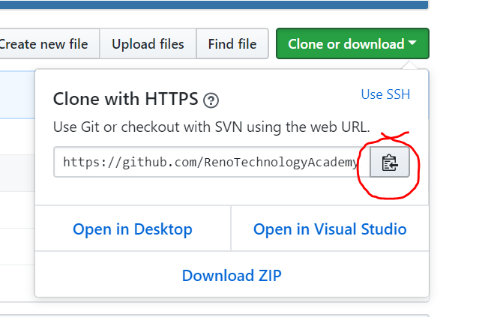

In the command prompt, use the command git clone {your web URL you copied}.

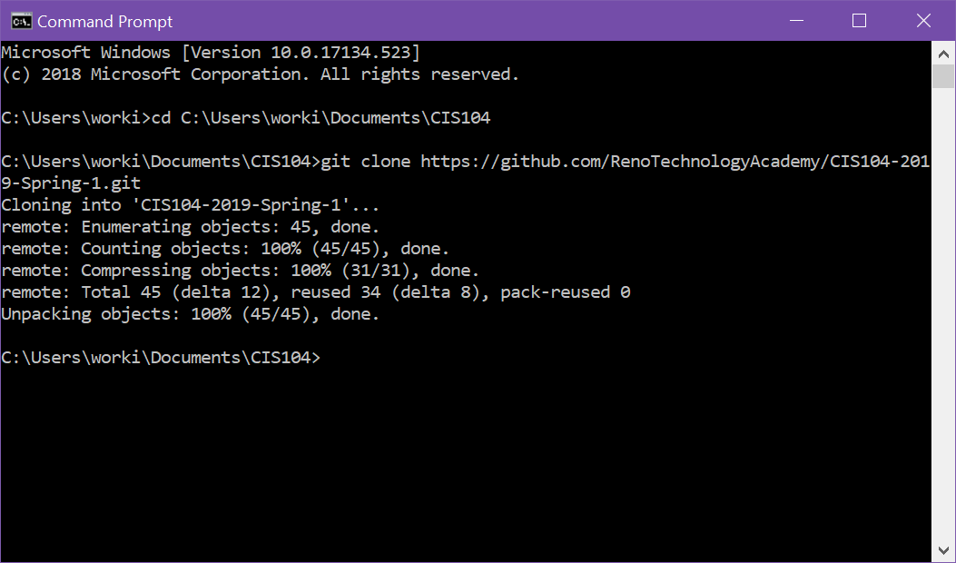

You should have all the files in your repository in a folder named the same name as your repository,

Navigate into your repository folder’s name. (My example is CIS104-2019-Spring-1)

Open VS Code from that location.

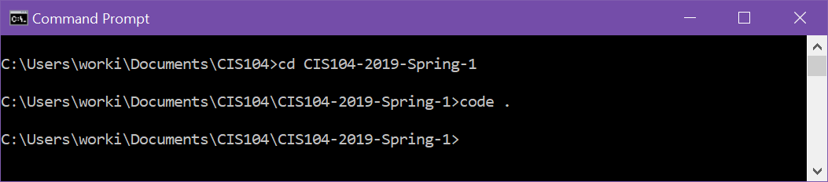

And you should see everything there.